Project Sprint #1

The Solitaire game is described in CS449HomeworkOverview. You should read the description very carefully.

In this assignment, you aim to specify the requirements (i.e., user stories and acceptance criteria) of the target software that allows a human player to play a Solitaire game. These requirements will be fully implemented by the end of sprint 3. The minimum features include choosing the board size and type, starting a new game, making a move, determining if a game is over. The following is a sample GUI layout.

Board size
7
Board Type  - English  - Hexagon  - Diamond | 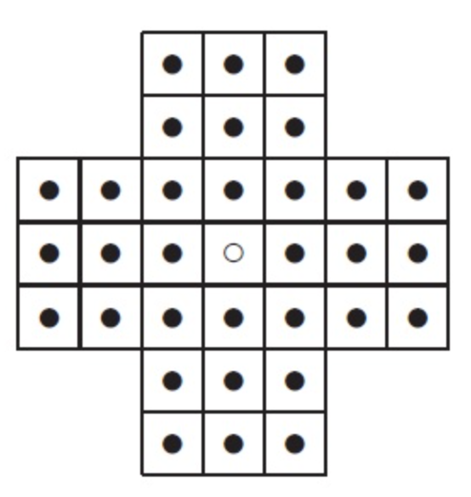 | New Game
Figure 1. Sample GUI layout of the first working program by the end of Sprint 3

Use the following tables to document your user stories and acceptance criteria.

You are required to use the free ChatGPT or another LLM to complete two user stories and two of their respective acceptance criteria. You must ensure that the generated user stories are correct and fix them if not. At the end of the submission, provide screenshots of your LLM prompts and answers, along with the description of errors the LLM made that you had to correct. Points will be deducted if no screenshots/description are provided.

For the other user stories and acceptance criteria, you are not required to use LLM.

- User Stories (3 points)

- User Story Template: As a <role>, I want <goal> [so that <benefit>]

ID | User Story Name | User Story Description | Priority | Estimated effort (hours)
1 | Choose a board size
2 | Choose the board type
3 | Start a new game of the chosen board size and type
4 | Make a move in a game
5 | A game is over

- Acceptance Criteria (AC) (12 points): Add/delete rows as needed.

User Story ID and Name | AC  ID | Description of Acceptance Criterion | Status (completed, toDo, inPprogress)
1. Choose a board size | 1.1 | AC 1.1 <scenario description>  Given  When  Then
1. Choose a board size | 1.2 | AC 1.2 <scenario description>  Given  When  Then
1. Choose a board size | …
2. Choose the board type | 2.1 | AC 2.1 <scenario description>  Given  When  Then
2. Choose the board type | …
…

